Title | Interactive Bar Chart with Plotly
Problem Statement | Create an interactive bar chart showing the population of different cities.
Objectives | • To understand interactive data visualization using Plotly.  • To create and organize city population data using a Pandas DataFrame.  • To develop an interactive bar chart for comparing the population of different cities.  • To analyze city-wise population by sorting values and identifying maximum, minimum, and average population.  • To save the interactive visualization as an HTML file and the dataset as a CSV file.
Dataset  URL Link /  File | City Population (Lakhs)  Mumbai 204  Delhi 167  Bengaluru 136  Hyderabad 108  Chennai 115  Kolkata 149  Source: Dataset provided in the Week 6 practice exercise.
Functions  Details | Sl. No. | Function | Package | Description of function
 | 1 | pd.DataFrame() | pandas | Creates a structured DataFrame from the city-population dictionary.
 | 2 | px.bar() | plotly.express | Creates an interactive bar chart using the selected x and y columns.
 | 3 | update_traces() | plotly | Updates trace properties such as the position of value labels on bars.
 | 4 | update_layout() | plotly | Modifies chart layout properties such as axis titles and labels.
 | 5 | show() | plotly | Displays the interactive Plotly figure inside the Jupyter Notebook.
 | 6 | sort_values() | pandas | Sorts DataFrame rows according to population values.
 | 7 | idxmax() | pandas | Returns the index of the row containing the maximum population value.
 | 8 | idxmin() | pandas | Returns the index of the row containing the minimum population value.
 | 9 | mean() | pandas | Calculates the average population of all cities.
 | 10 | loc[] | pandas | Selects rows and values from the DataFrame using an index or label.
 | 11 | write_html() | plotly | Saves the interactive Plotly chart as an HTML file.
 | 12 | to_csv() | pandas | Exports the DataFrame to a CSV file without the index column.
Steps/  Process/  Procedure/  Algorithm/  Flowchart/  Model | 1. Import the required libraries: Pandas and Plotly Express.  2. Create a dictionary containing the names of six cities and their population values in lakhs.  3. Convert the dictionary into a Pandas DataFrame.  4. Display the DataFrame and verify its shape, city names, and population values.  5. Create an interactive bar chart using Plotly Express with City on the x-axis and Population (Lakhs) on the y-axis.  6. Display population values above the bars and add suitable chart and axis titles.  7. Sort the DataFrame by population in descending order and display the sorted data.  8. Generate a second interactive bar chart using the sorted population data.  9. Identify the city with the highest population using idxmax() and the city with the lowest population using idxmin().  10. Calculate the average population using mean().  11. Display a final city population analysis summary.  12. Save the interactive chart as an HTML file and save the dataset as a CSV file.
Program | import pandas as pd  import plotly.express as px  data = {  "City": ["Mumbai", "Delhi", "Bengaluru", "Hyderabad", "Chennai", "Kolkata"],  "Population (Lakhs)": [204, 167, 136, 108, 115, 149]  }  df = pd.DataFrame(data)  print(df)  print("Dataset Shape:", df.shape)  print("\nCities:")  print(df["City"].tolist())  print("\nPopulation:")  print(df["Population (Lakhs)"].tolist())  fig = px.bar(  df,  x="City",  y="Population (Lakhs)",  title="Population of Major Indian Cities",  text="Population (Lakhs)"  )  fig.update_traces(textposition="outside")  fig.update_layout(xaxis_title="City", yaxis_title="Population (Lakhs)")  fig.show()  sorted_df = df.sort_values(by="Population (Lakhs)", ascending=False)  print(sorted_df)  fig = px.bar(  sorted_df,  x="City",  y="Population (Lakhs)",  title="City-wise Population Analysis",  text="Population (Lakhs)"  )  fig.update_traces(textposition="outside")  fig.update_layout(xaxis_title="City", yaxis_title="Population (Lakhs)")  fig.show()  highest = df.loc[df["Population (Lakhs)"].idxmax()]  print("City with Highest Population:")  print(highest)  lowest = df.loc[df["Population (Lakhs)"].idxmin()]  print("Lowest Population:", lowest["City"], "-", lowest["Population (Lakhs)"], "Lakhs")  average_population = df["Population (Lakhs)"].mean()  print("Average Population:", round(average_population, 2), "Lakhs")  print("CITY POPULATION ANALYSIS")  print("-" * 35)  print("Total Cities:", len(df))  print("Highest Population:", df.loc[df["Population (Lakhs)"].idxmax(), "City"])  print("Lowest Population:", df.loc[df["Population (Lakhs)"].idxmin(), "City"])  print("Average Population:", round(df["Population (Lakhs)"].mean(), 2), "Lakhs")  fig.write_html("city_population_chart.html")  print("Interactive chart saved successfully.")  df.to_csv("city_population.csv", index=False)  print("Dataset saved successfully.")
Output Snapshots  With  Explanation/  Observations | Output Snapshots and Observations  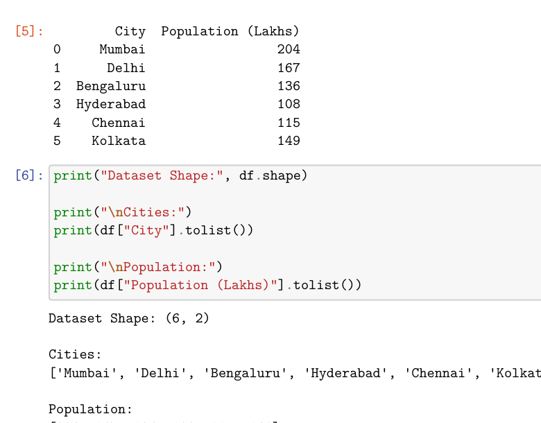  Fig. 1.1: DataFrame and Dataset Verification  Explanation/Observation: The city-population dictionary was converted successfully into a Pandas DataFrame containing 6 rows and 2 columns. The output verifies all six city names and their population values.  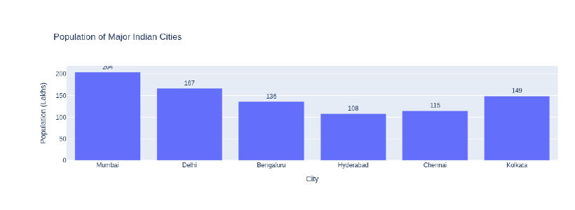  Fig. 1.2: Interactive Population Bar Chart  Explanation/Observation: Plotly generated an interactive bar chart showing population values for Mumbai, Delhi, Bengaluru, Hyderabad, Chennai, and Kolkata. Hover, zoom, pan, and reset controls are available in the interactive notebook view.  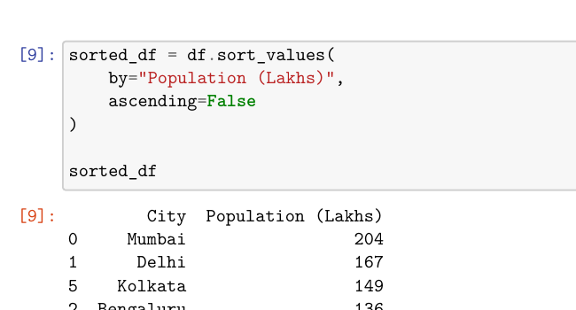  Fig. 1.3: Population Data Sorted in Descending Order  Explanation/Observation: The DataFrame was sorted using sort_values(). Mumbai appears first with 204 lakhs, followed by Delhi, Kolkata, Bengaluru, Chennai, and Hyderabad.  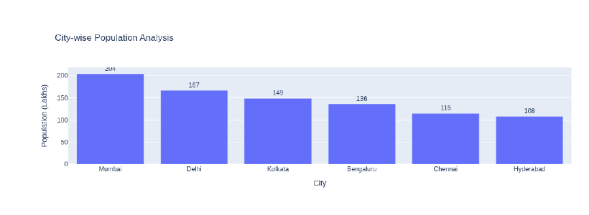  Fig. 1.4: City-wise Population Analysis  Explanation/Observation: The sorted interactive chart makes comparison easier by arranging the cities from highest to lowest population.  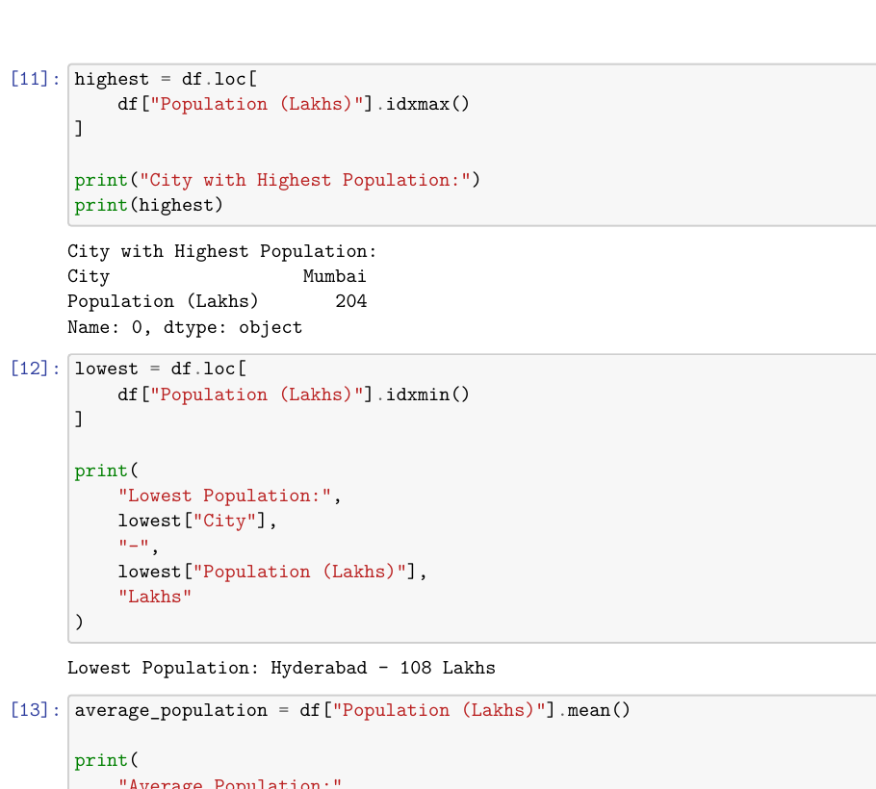  Fig. 1.5: Highest, Lowest, and Average Population Analysis  Explanation/Observation: The analysis identifies Mumbai as the highest-population city with 204 lakhs, Hyderabad as the lowest with 108 lakhs, and the average population as 146.5 lakhs.  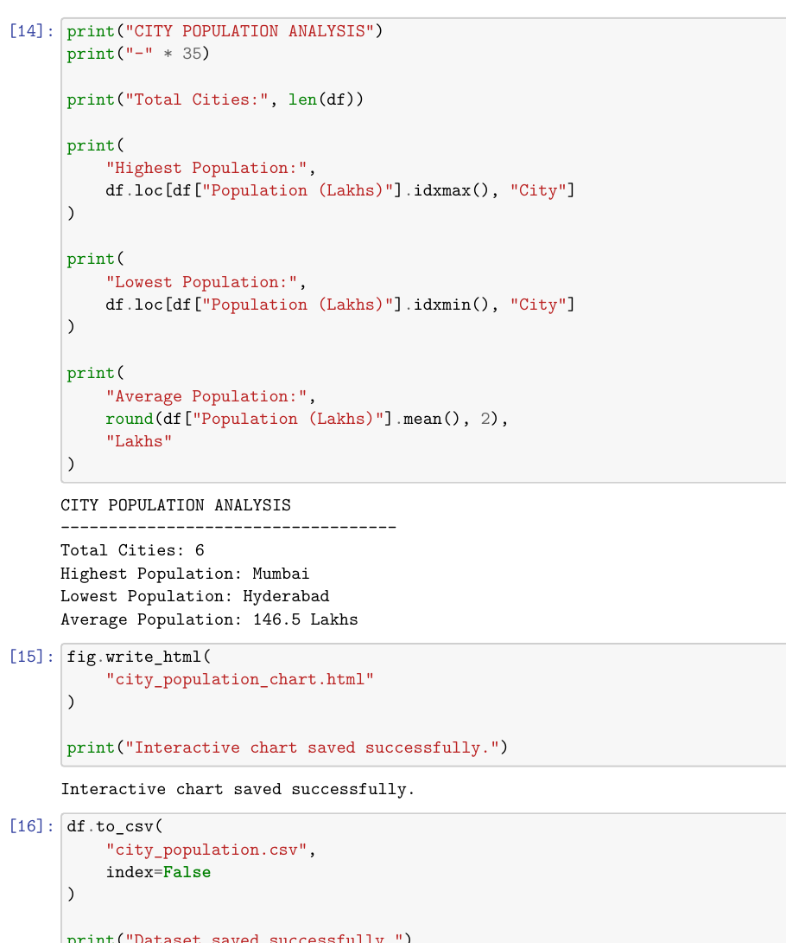  Fig. 1.6: Final Population Summary and File Export  Explanation/Observation: The final summary reports 6 cities, the highest and lowest population cities, and the average population. The interactive chart was saved as city_population_chart.html and the dataset was saved as city_population.csv.
Conclusions | The experiment was successfully completed using Pandas and Plotly. The population data of six major Indian cities was organized in a Pandas DataFrame and visualized using interactive bar charts. The data was sorted for comparative analysis, and Mumbai was identified as the highest-population city while Hyderabad had the lowest population. The average population was calculated as 146.5 lakhs. The interactive visualization was successfully saved as an HTML file and the dataset was exported as a CSV file.
References | 1. Michael Freeman and Joel Ross, Programming Skills for Data Science: Start Writing Code to Wrangle, Analyze, and Visualize Data with R, Addison-Wesley, 2018.  2. Python Program (GitHub link):  3. Class lecture link: https://drive.google.com/file/d/1DTrgSSfuw7NhFuCiIVclzBqrlMki4V4d/view

